**Name** : Sakshi Raju Yadav **Date**: 11/04/2024

1. Create databases with names "empdatabase" and "studentdatabase".

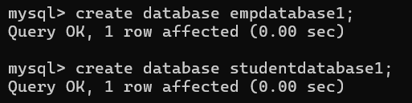

**2**.Create a table under empdatabase with name “emp” with columns id,name,dept,sal and experience.

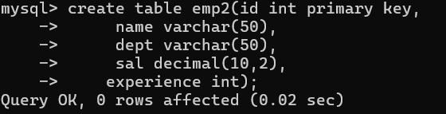

**3**.Insert a minimum of 5 employees' data records into the emp table

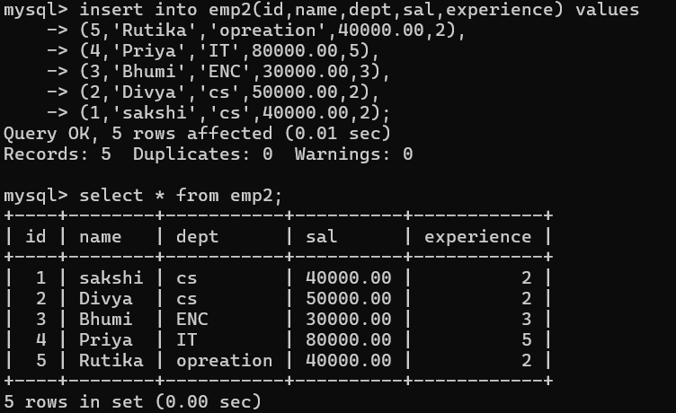

**4**. Create a table under studentdatabase with name "std" with columns rno, name, dept, year and college.

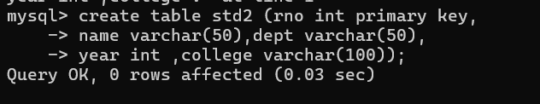

**5**. Insert a minimum of 5 students' data records into the std table.

